Analysis of Risk Content on Social Media Related to Suicide, Self-Harm and Eating Disorders

(March 2026)

ÍNDICE
1. Introduction 4
2. Metodología 7
3. TikTok 7
4. X (Antes Twitter) 9
5. Facebook 11
6. Instagram 13
7. YouTube 14
8. Referencias 15

- Introduction

For several years, social networks and digital platforms have reshaped the way people communicate, construct their identities and access information, particularly among adolescents and young people. These spaces—often without parental or professional filters or supervision—have become central settings in which complex mental-health realities are discussed, shared and represented, including suicide, self-harm and eating disorders. Social networks have become, especially for younger users, the new agora for meeting, debate and reflection. Analysing how these discourses are produced and circulate in the digital environment is therefore a matter of public interest.

Worldwide, suicide remains a major public-health problem. More than 720,000 people are estimated to die by suicide each year, making it one of the leading causes of death among people aged 15–29 (WHO, 2025). In Spain, 3,953 suicide deaths were recorded in 2024, corresponding to a rate of 8.1 per 100,000 inhabitants (INE, 2025).

Clinical research in Spain indicates that hospitalisations for suicidal behaviour among adolescents have quadrupled over the past two decades. Young people account for approximately 73% of these hospitalisations, with a median admission age of 16 (Soriano et al., 2024). Beyond mortality figures, suicidal thoughts and behaviours—including attempts and emergency hospital admissions—are therefore increasingly important, particularly among young people. Available mental-health data also show that a considerable proportion of young people in Spain have experienced self-harm or suicidal ideation at some point in their lives, with gender differences requiring specific attention (Díaz de Neira et al., 2015).

Eating disorders, including anorexia nervosa, bulimia nervosa and other disorders, are also a significant public-health concern among children and adolescents. Studies of schoolchildren in Spain suggest that 18–31% of adolescents may be at risk of developing an eating disorder; 23–31% have experienced suicidal ideation, and 2.2–6.2% report suicidal behaviours (Gómez-Romero et al., 2024).

A recent observational study by a multidisciplinary team from the University of Córdoba and the Maimonides Biomedical Research Institute of Córdoba highlights a significant association between self-esteem, body perception and the risk of developing an eating disorder in the context of social-media use. It also warns that problematic use of these platforms—whether because of excessive time spent on them or the nature of the content accessed—increases this risk, particularly when social networks become a primary source of information and reference for young people (Pérez-Jiménez et al., 2025).
Public authorities’ actions to identify and prevent risks that may affect children and adolescents must be guided by the principle of the best interests of the child, enshrined in Article 3 of the United Nations Convention on the Rights of the Child. This principle is also established in Articles 2 and 3, respectively, of Organic Law 1/1996 of 15 January on the Legal Protection of Minors and Law 4/2021 of 27 July on Children and Adolescents in Andalusia. Article 2 of the aforementioned Organic Law provides that every minor has the right for their best interests to be assessed and considered as a primary consideration in all actions and decisions concerning them, both in the public and private spheres. In the application of this law and other relevant legislation, as well as in measures concerning minors adopted by public or private institutions, courts or legislative bodies, the best interests of the child shall prevail over any other legitimate interest that may be involved.
Organic Law 8/2021 of 4 June on the comprehensive protection of children and adolescents against violence devotes Chapter VIII to new technologies and expressly recognises the risks arising from inappropriate use. This is a reality that must be addressed through the exercise of the powers entrusted to the various institutions at both national and regional level in the areas of child protection, compliance with the law, the rights of the parties involved, and the safe use of technology.

Within this regulatory framework, and in view of an emerging reality that is becoming a significant challenge from a public health perspective, with a particular impact on children and young people, the CAA considers it appropriate to undertake the present study.

- Methodology
This study briefly analyses the behaviour of the internal search engines of various social media platforms when the term “suicide” is entered, as well as the terms most commonly used on social media to share content relating to self-harm and eating disorders (EDs). The aim has been to empirically examine the automated moderation systems, preventive warning mechanisms and, where applicable, access restrictions applied to potentially sensitive content on each of the platforms analysed (TikTok, X, Facebook, Instagram and YouTube). The tests were conducted through direct searches under standard usage conditions, with the aim of approximating the experience of an average user.
This report does not expressly include or identify the specific terms, expressions or hashtags used during the research to locate content related to suicide, self-harm and eating disorders. This decision reflects preventive responsibility criteria, as the explicit mention of such terms could create a contagion, imitation or normalisation effect, facilitating their reuse by third parties to intentionally search for this type of content in digital environments.
- TikTok
This social network has completed and automatic restrictions when the word “suicide” and similar terms are entered into its search engine, both in Spanish and in English, Italian or French. In fact, it displays a message stating, “You are not alone”, along with web buttons for “Access resources”, providing the number for the Teléfono de laEsperanza (Hope Telephone): 717 003 717.
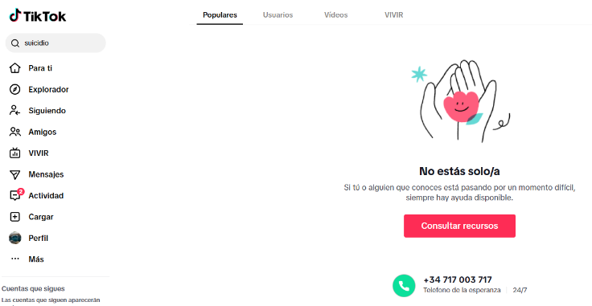
As part of this initial analysis, searches were also conducted using terms whose spelling had been partially or completely altered, as is commonly done in an attempt to circumvent potential control mechanisms and locate content relating to suicide. In most cases, the results provided by the algorithm correspond to accounts from people who have attempted suicide or from their family members, as well as preventive videos or content related to grieving processes. Among the posts analyzed, some were also identified as containing direct references to suicidal ideation.

With regard to content related to self-harm, searches for some of the terms most commonly used in digital environments to locate this type of post do not return any results and immediately trigger the same preventive message displayed when searching for terms related to suicide.
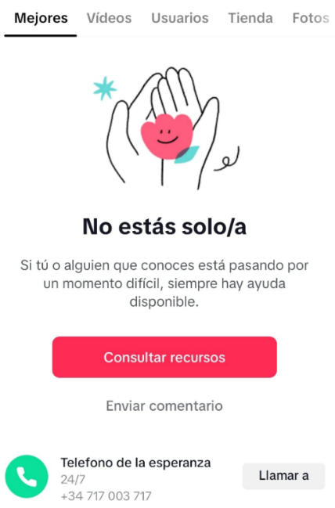
However, when other terms related to this subject are used, it is possible to access a heterogeneous range of content, including preventive and deterrent materials, contributions from healthcare professionals aimed at providing support to families, and personal accounts from users sharing their own experiences.
Although, at this initial stage of the analysis, no content directly encouraging self-harm has been identified, the responses to users sharing their personal experiences do reveal the development of group dynamics and a sense of community. Furthermore, it has been observed that, on some occasions, the text embedded in videos shared on this platform also contains deliberate alterations to characters in an attempt to circumvent automated moderation systems.
Finally, it should be noted that TikTok appears to have a system that discourages initial searches for content related to eating disorders (EDs). For example, when the most common terms used by this community on social media are entered into its internal search engine, the platform does not return any results and instead displays the following help message:

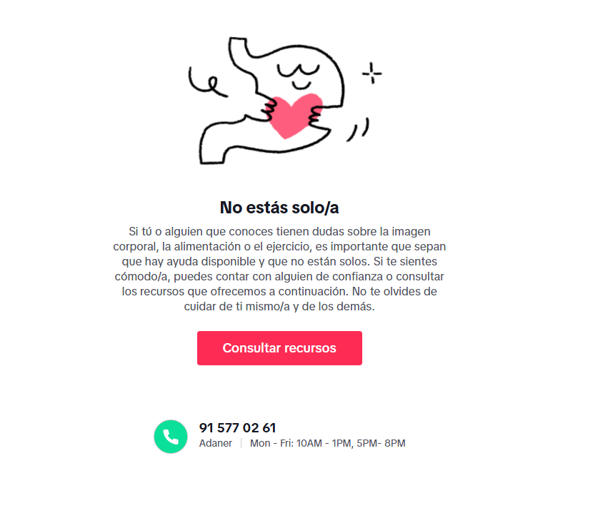

However, when variants of these terms are used by replacing letters with numbers or other characters—a practice that is widespread among young users seeking to circumvent automated filters on various sensitive topics—and the results page is scrolled through, it is possible to locate videos from pro-ED accounts promoting potentially dangerous behaviors that may pose risks to health. Among the content analyzed, messages were identified sharing guidelines for extreme weight loss, as well as instructions on how to encourage the platform’s algorithm to increase the appearance of videos of this type. In addition, these posts contained numerous links to private WhatsApp groups, some of which describe themselves as “toxic”, designed as closed spaces for the exchange of advice and experiences relating to these practices.
- X (Before Twitter)
When searches are conducted using certain terms related to suicide and their semantic variants, in Spanish as well as in English, Italian or French, the platform initially displays a notice aimed at prevention and encouraging users to seek help.
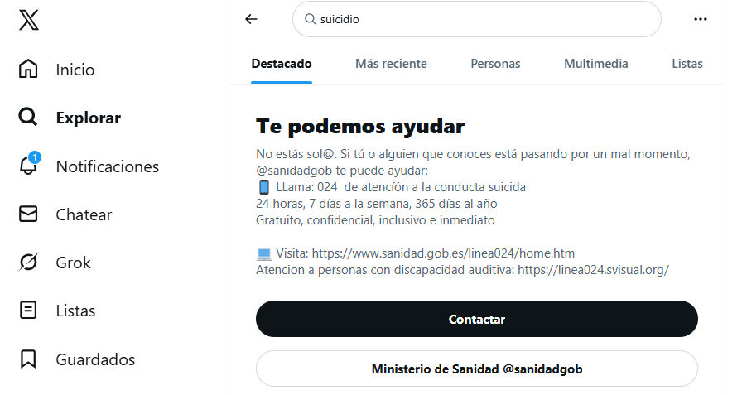
However, following this initial warning, the system displays results associated with the search term entered. These contents fall into various categories, including informational, testimonial and opinion-based materials. Among the results analysed, at least one post was identified expressing suicidal ideation. In response to this post, several users, rather than adopting a discouraging or supportive approach, encouraged the person to act on the decision, with messages such as “well, instead of talking about it, do it.”
Furthermore, the investigation found that explicit self-harm videos are accessible on X through direct searches in the platform’s search engine, using multiple hashtags that facilitate their discovery. From this content, users can easily navigate to similar profiles and posts shared by other accounts, as well as to hashtags frequently used within these communities. It is worth noting that the comments on many of these posts show a tendency to glorify self-harming behaviour, including expressions of admiration for those who engage in it. In some cases, the authors of the posts themselves encourage other users to replicate such behaviour.
The analysis also found that X returns results when searching for terms and hashtags commonly used in pro-eating-disorder (pro-ED) digital environments. Although searches for these hashtags do not trigger warning messages or apparent restrictions, some users state in replies to the monitored posts that they perceive greater limitations when attempting to publish certain messages related to this subject compared with earlier periods of the social network.
The hashtags analysed make it possible to identify and group posts relating to personal experiences involving food, with messages ranging from mutual support among people interested in weight loss to the normalisation of potentially harmful health practices. In particular, one hashtag was identified as concentrating a significant volume of this type of content. This term is used to designate certain subcommunities within the X social network where messages related to eating disorders are shared recurrently, including content that may pose a potential risk to health and, in some cases, to life.

Among other examples, the analysis identified posts sharing advice on losing weight rapidly, described as “toxic” by the account publishing them. Although, in this case, each recommendation included a warning about its potentially harmful effects on health, the responses to the original post demonstrated a high level of acceptance of these recommendations, which included using laxatives or consuming only coffee throughout the day.

Content portraying extreme thinness as an aspiration can also be accessed easily, as can posts expressing hatred of food, lamenting the “forced” consumption of food, or seeking company to undertake a five-day fast. An offensive post was also identified, in which a user asks whether “any fat girl wants me to bully her to help her lose weight.”
- Facebook
When the term “suicide” is entered into this platform’s search engine, the system activates a message stating “Get help” and warns that the search term may be associated with sensitive content. The platform’s overall behaviour is similar to that observed on TikTok. Searches related to self-harm also trigger the same help message. Another aspect worth noting is that Facebook does not even recognise some of the terms searched, despite their widespread use on other platforms to access this type of content.
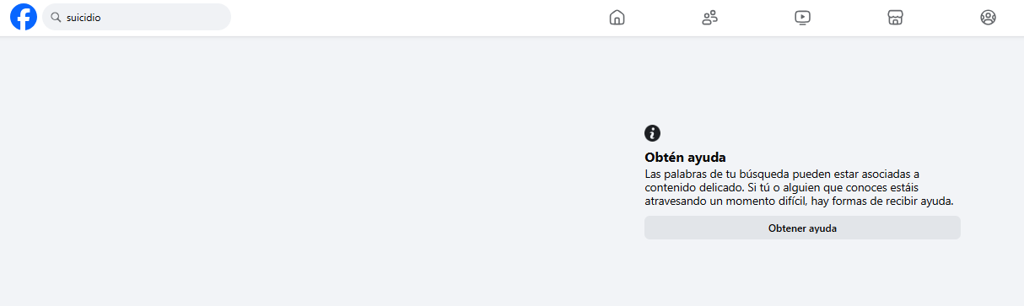
In turn, this social network, which is increasingly less used by adolescents, effectively limits the results returned when certain concepts promoting anorexia and bulimia are searched, offering only help and support resources. However, when other terms commonly used in digital environments related to eating disorders (EDs) are entered, the platform not only displays the aforementioned preventive resources but also gives users the option of accessing the search results.
In this regard, it should be noted that the results obtained from the terms analysed during this study did not contain any content that could, a priori, be classified as harmful to health. The results mainly consisted of support groups and spaces. However, some of these groups are private, which makes it impossible to determine precisely what type of content is shared within them.

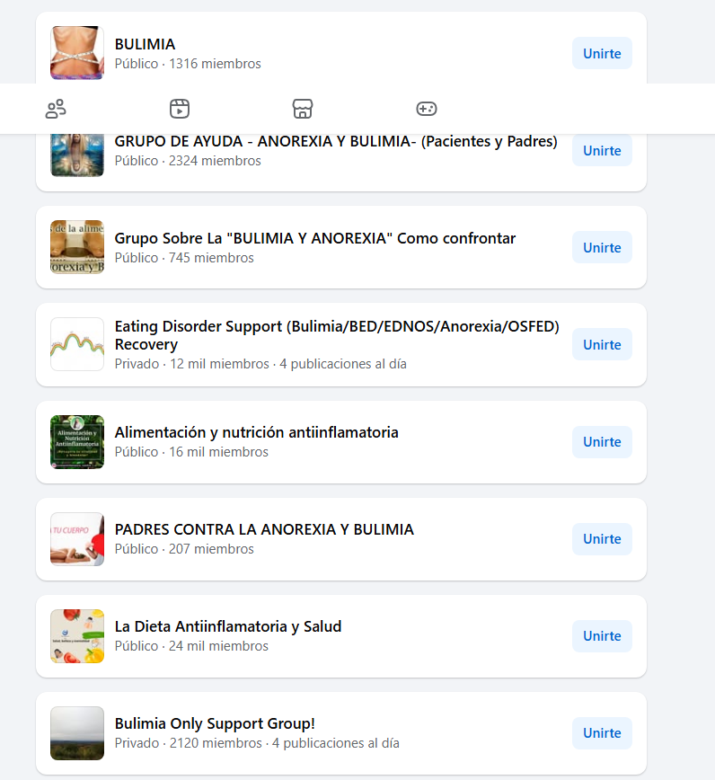

- Instagram
The platform incorporates preventive intervention mechanisms by displaying help messages when searches are conducted for the term “suicide”, as well as for terms related to self-harm and eating disorders (EDs). In these cases, the search engine does not return results associated with these terms, thereby blocking access to the corresponding content. This limitation also applies to several hashtags commonly used on other social networks to identify or disseminate this type of post.
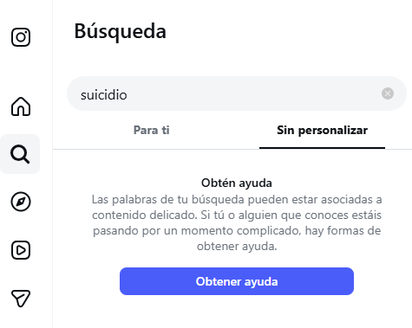
It was also found that searches using generic terms related to self-harm return content associated with the subject, predominantly featuring messages of help, support and prevention. In this initial assessment, no posts directly encouraging such practices or containing explicit images of the acts were identified. However, in the replies to some of these preventive posts, certain users share personal experiences, describe techniques they have used, and express suicidal ideation.
- YouTube
In this case, when the words “suicide” or “self-harm” are searched, the platform returns a help panel displaying the message “We are here for you”, together with a link to Spain’s Ministry of Health and the 024 suicide behaviour support helpline. However, immediately below this message, users are given the option to view videos, after first receiving a warning stating that “the following results may refer to suicide or self-harm” through the link “Mostrar de cualquier forma”.
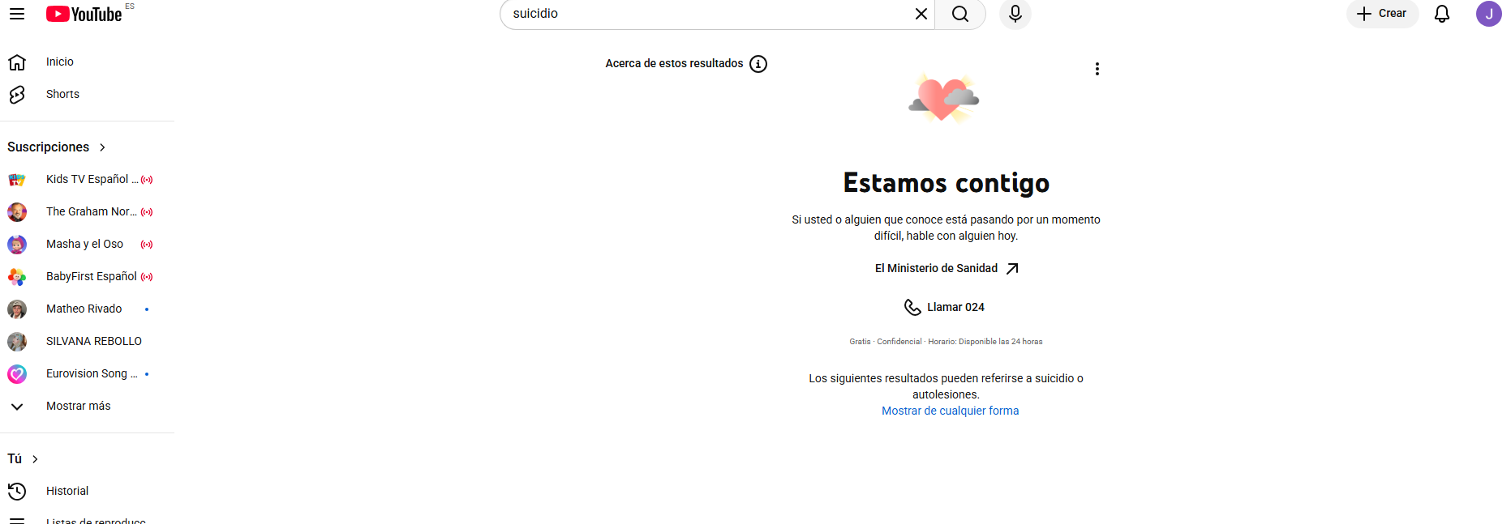
The videos identified during this analysis primarily consist of support and prevention content, either through personal testimonials or material produced by healthcare professionals who emphasise the importance of prevention. They do not, however, provide guidance that could encourage or facilitate self-harm.
Likewise, on this platform, searches for terms commonly associated with eating disorders return results. Nevertheless, in this initial assessment, no content directly encouraging or promoting behaviours that pose a risk to health was identified. The results obtained mainly consist of content unrelated to the promotion of harmful practices, such as media publications explaining the meaning of these terms, opinions from healthcare professionals, support resources aimed at families, and awareness campaigns.
- References
Díaz de Neira, M., García-Nieto, R., de León-Martínez, V., Pérez Fominaya, M., Baca-García, E., & Carballo, J. J. (2015). Prevalence and functions of self-injurious thoughts and behaviors in a sample of Spanish adolescents assessed in mental health outpatient departments. Revista de Psiquiatría y Salud Mental, 8(3), 137–145. https://doi.org/10.1016/j.rpsm.2013.09.003
Gómez-Romero, M. R., Montoro-Pérez, N., Martín-Baena, D., Talavera-Ortega, M., & Montejano-Lozoya, R. (2024). A descriptive cross-sectional study on eating disorders, suicidal thoughts, and behaviors among adolescents in the Valencian community (Spain): The pivotal role of school nurses. Journal of Pediatric Nursing, 75, 1–7. https://doi.org/10.1016/j.pedn.2023.11.027
Instituto Nacional de Estadística. (2025). Defunciones por suicidio. Año 2024. https://www.ine.es/jaxi/Datos.htm?tpx=76978
Pérez-Jiménez, M., Uclés-Torrente, M. D. M., Ruiz-Gamarra, G. E., Vaquero-Álvarez, M., Blancas-Sánchez, I. M., Aparicio-Martínez, P., & Vaquero-Abellán, M. (2025). Social media consumption and risk of addiction associated with adolescent disordered eating behaviour: An observational analysis. Nutrients, 17(18), Article 3017. https://doi.org/10.3390/nu17183017
Soriano, V., Ramos, J. M., López-Ibor, M. I., Chiclana-Actis, C., Faraco, M., González-Cabrera, J., González-Fraile, E., Mestre-Bach, G., Pinargote, H., Corpas, M., Gallego, L., Corral, O., & Blasco-Fontecilla, H. (2024). Trends in suicidal behavior among hospitalized adolescents in Spain over two decades. Journal of Affective Disorders, 363, 106–111. https://doi.org/10.1016/j.jad.2024.07.081
World Health Organization. (2025, March 25). Suicide. https://www.who.int/news-room/fact-sheets/detail/suicide

